Sample DOcument For Reference

Only to expose my style of writing

Table of Contents

1. Introduction 2

2. User Management 3

2.1. Add User 3

2.1.1. Adding a new User 3

2.1.2. Searching an Existing User 4

Figure 1: User Management (Add User) 3

Figure 2: Search User 4

# Introduction

This tool is an enterprise-wide platform that enables end-to-end management of alerts or exceptions from disparate systems .It is highly scalable and is a configurable solution with the ability to integrate seamlessly with upstream and downstream systems leveraging investments made in existing infrastructure. It has a modular and platform independent architecture that supports multiple interfaces in prompting alerts, data import such as database listeners, message queues, batch files and web services. Its three-tier component based architecture enables scalability, data security and maintainability.

# User Management

User management allows the addition of new users, search users. All the platform users are defined with the scope of functionalities. The users are authorized to access the functionalities based on their roles. User management module allows you to manage platform Users account. This helps in managing the database of users. User Management allows setting up multiple roles belonging to multiple departments to a single user

User management includes the following Submenus:

* Add User
* Search User
* Assign Team Lead

## Add User

Add User helps to add multiple users who will be using this platform.

### **Adding a new User**

The figure displays the User Management ‘**Add User**’ functionality,

Go to **Administration -**> **User management** -> **Add User**

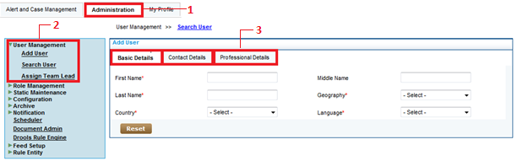

Figure 1: User Management (Add User)

To add a user, do the following:

1. Login to the application as an **Admin User**.
2. Click on the **Administration**.
3. Click **User Management** on the left navigation pane and then click **Add User**.
4. Click on the **Add User** to add a new user.
5. Enter the **Basic Details** with mandatory fields.
6. Enter the **Contact Details** with all the given fields.
7. Enter the **Professional Details** with mandatory fields.
8. Click on S**ave**, to save the New User.
9. Click on **Reset** to reset details of existing user.

* Mandatory fields are highlighter with ‘*’

### **Searching an Existing User**

Searching an existing user will help to search multiple users which are already added in the platform and also search user facility can be used for quick search and edit user information/ role. User can view the data by dynamically selecting the filters and display attributes.

Go to **Administration** -> **User Management** -> **Search User**

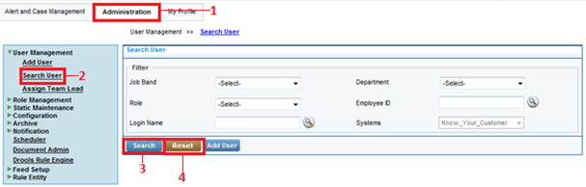

Figure 2: Search User

##### 

To search an existing user, do the following:

1. Login to the application as an **Admin User**.
2. Click on the **Administration** button.
3. On the left navigation pane, click **User Management** and then click **Search User**.
4. Enter the field by which user needs to filter the data.
5. Click on the **Search** to view the details of existing user.
6. Click on **Reset** to reset the details of existing user.

* The system displays the ‘Search Result’
* Output data is controlled as per user access security norms limiting the permissible data to be seen by respective user.